02.02
AIRCRAFT PHASE-OUT
Process Design & AMOS Configuration Document
Purpose
This Process Design document is provided to Key-Users to record their key decisions regarding the AMOS Process design and the required AMOS configuration.
It is updated throughout the Project Definition Phase and used as the baseline for the Final Acceptance prior to Go-Live
Revision
Author, Name | Date | Notes
Swiss-AS, Consulting | 01.06.2024 | First Version
Dimitri Dupont | 21.11.2021 | Revision 1

Table of Contents
1. Process Overview & Objectives 3
2. Regulatory References 3
3. Definitions & Glossary 3
4. Process Tasks 3
5. Process Dependencies 4
6. Process Flow 5
7. Process Design Questions 7
8. Data Source Mapping 11
9. Other Software Used 11
10. AMOS Configuration 12
a. Process specific configuration programmes 12
b. Basic Data 12
c. Parameters 13
d. Workflows 15
e. Scheduled Tasks 15
f. API’s & Interfaces 16
11. UAT Guidance 17
12. Annex – Additional Info 17

Process Overview & Objectives
Process General Description:
This process describes how to extract all the mandatory airworthiness data that are needed for the future operator, and to inactivate the aircraft in the customer’s system.
Main Process Objective (Outputs & Outcomes):
The main objective of this business process is to extract aircraft data from the system and once this is done to inactivate the aircraft in AMOS.
Extracting data is mandatory to allow the future operator to phase in the aircraft in his fleet with required and up to date airworthy data.
Once the aircraft is inactivated/archived, any actions regarding this tail number will be forbidden. Nonetheless, all recorded information remains in AMOS and are accessible..

Regulatory References
- EASA M.A.307 Transfer of Aircraft Continuing Airworthiness Records.
- EASA M.A.305 Aircraft Continuing Airworthiness Record System
- EASA CAMO.A.220 Record-keeping
- EASA 145.A.55 Record-keeping

Definitions & Glossary
Key-Words | Explanation
-/- | -/-

Process Tasks
There is two ways to extract the various reports during the phase out of an aircraft. Either manually or using the possibility to extract the required information using S2500D format files.

As the extract using the S2500D format is included in another process, it will not be developed in this document.
Business Process Task / Actions / Activities:

  - Extract installed components, assemblies and software

A/C Equipment list: List of all P/N & S/N, date of installation and TSN/CSN of parts installed.
A/C Software: List of all recorded installed software (SW Part No, Type, Description, installation date ...)
A/C modification status report: List of all the modification with type, Number, description and status.
A/C taskcard history: with last performed information and reference to the WO.

A/C Modification Status Report: List of all the modifications applied to the aircraft.
A/C Open defects: List of all open defects at the time of removal from fleet, if any.
A/C W&B Report: List of all the recorded weight & balance modifications, either calculated or physically performed.
A/C Structural damage report: report containing all the recorded damages and the location on the aircraft, including approximate location on charts.
A/C Status Report: Global Status of the aircraft and forecasted event in a defined time range. The information in this report can be easily tailored with the option provided directly in the APN 476.
  - Archive/Deactivate aircraft.
The archiving/deactivation of the aircraft consist of deleting all installed rotables, close all open orders, deactivate pending maintenance events, etc... and finally de-activate the aircraft.
Note that only when all tickboxes are ticked, and after confirming twice that the aircraft will be de-activated.
Note that archiving/deactivation of the aircraft renders it unusable for future actions.

Process Dependencies
INPUT | CONCURRENT | OUTPUT
- 01.01 – Aircraft definition  - 01.03 – Aircraft Maintenance program  - 01.04 – Sb & AD assessment  - 01.05 – Configuration Management  - 01.06 – MEL administration  - 01.08 – Weight & Balance  - 02.07 – Structural Damages | -/- | -/-

Process Flow

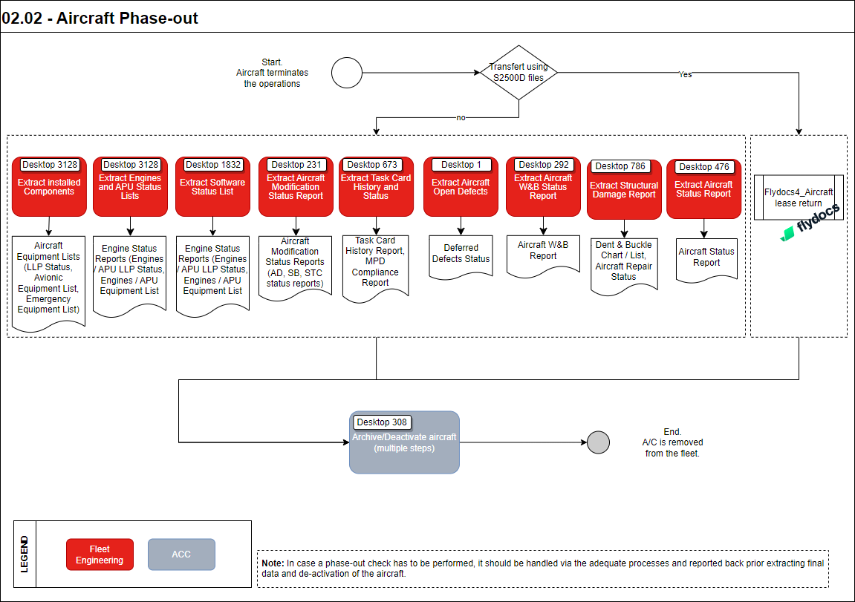

Process Design Questions
# | Question | Answer
-/- | -/-

Data Source Mapping
Data Sources | Description | Volume / Manual / Automatic / Static / Dynamic
-/- | -/- | -/-

Other Software Used
Other Software | Used by: | Description
-/- | -/-

AMOS Configuration

Process specific configuration programmes
AMOS APN | Notes
-/- | -/-

Basic Data
Basic Data Table | Notes
-/- | -/-

Parameters
Parameter Code | Parameter Name | Notes
-/-

Workflows
Workflow Number | Workflow Name | Workflow Setup Notes
-/-

Scheduled Tasks
Scheduled Task Reference | Frequency | Notes
ExtractTaskcardDueValues | -/- | If future operator uses AMOS, this extract file can be loaded as XMSTASPREST and XMSTASKPENDINT, after adjustments of the aircraft registration.
-/- | -/- | -/-

API’s & Interfaces
Reference | Direction | Trigger | Frequency
-/-

UAT Guidance
Test case number | Test case description | Required data | Required resources
1 | Extract latest up to date airworthiness data after end of lease/resale of an aircraft from the fleet. | Tasks list, Last Performed / Next Due, part list, modification list, W&B report and structural damage report | Engineering
2 | Archive/Deactivate the aircraft |  | Engineering
-/- | -/-

Annex – Additional Info
-/-

